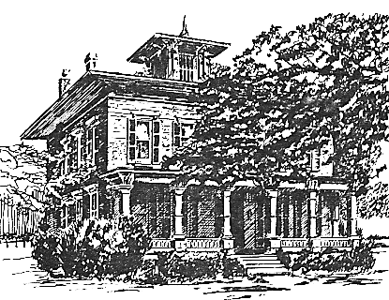
September 2022 NEWSLETTER

Message from the President:
Hello! Summer flies by so quickly! After our glorious 4th of July celebration our attention was directed to the Shake on the Lake performance scheduled for late July. A COVID outbreak delayed it to early August, but the small cast did a great job of presenting their version of MacBeth before a crowd of nearly 100. Thanks to the Village of Brockport for sponsoring this fun lawn event.
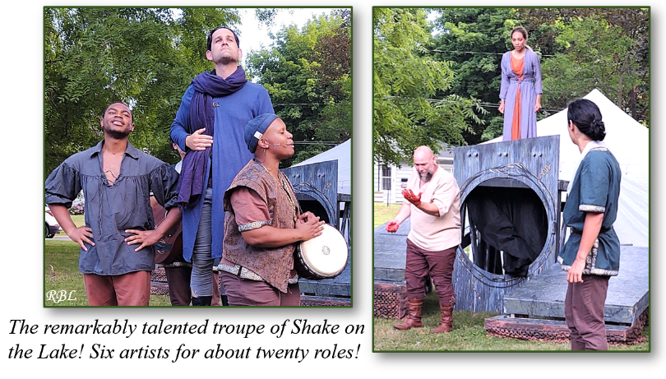
Also requiring thanks are the docents who provided Sunday tours this summer. Rozenn was able to train new volunteers who love the House and the Morgan family history.
Upkeep of any home is continuous, and Gordy Fox has been especially busy. Besides his usual fixing, replacing, and painting, he has had the unenviable task of finding, calling and meeting with contractors for the larger jobs on hand. Getting estimates has not been a quick process, but we were able to have roof repairs completed, as well as the wonderful restoration of the spire atop the belvedere. Gordy took care of fresh coats on the porches, but some additional exterior painting work is needed. Those discussions are in progress right now. Many thanks to Gordy!
My attention has been split between the office and the Carriage House. Staff illness and vacation time have made for just a bit more administrative work. The wonderful number of donations for the Carriage House Sale to be held during Peddlers' Market has made for a lot of work. Thank you for that! Some wonderful volunteers have made this process lots of fun, and we have been inventive in order to display as much treasure as possible in the best possible way. We still need volunteers for that day. Be sure to sign up soon!
Mary Lynne Turner, President.
Quick Reminder that our annual Peddlers Market is September 10th, rain or shine, 9 am to 2 pm, on the grounds of the Morgan-Manning House. Do not miss all the bargains at the Carriage House Sale. All the proceeds of the Carriage House Sale benefit the Society!
Book Reading with Mark Chesnut at the MMH on September 29:
Many of us who remember our first WMHS Historian, Eunice Chesnut, own a few of her books on local history. Her son Mark is now an award-winning travel writer who has written a book of his own, a charming memoir.
Prepare for Departure is an amusing and cohesive collection of stories of his early life in Brockport with his widowed mother up to the decision to move her to NYC so that she could be closer to him and his sister for her final months.
We are pleased that Mark will be the guest of honor at the Morgan-Manning House on Thursday, September 29, from 6 to 8pm. He will give a reading and be available to sign copies of his book. The Lift Bridge Book Shop is co-sponsoring the event and will have copies available for purchase. It might be a good idea to pick one up now at Lift Bridge, or order one, to be sure that you get one.
Curator’s Corner – A recent stay at my parents’ house, in France, has made me realize how grateful I am to have air conditioning here, in my office. As you may have read in the news, most of Europe has been experiencing a dreadful heatwave since the beginning of June. While I was in Brittany, temperatures daily reached 90-95º. You may think, “What is the big deal? We have such heat waves here too!”. In my village, however, such hot days were unusual until recently. Consequently, air conditioning and fans have yet to be standard features of most homes! I wholeheartedly was able to sympathize with the Victorian Americans, who only had hand fans at their disposal to cool themselves.
The Morgan-Manning House collection of clothing accessories includes a selection of such hand fans, which, as was the case with many clothing-related items of the Victorian period, provided more than just a means to cool oneself; they also served as fashion statements, status symbols, and even political advertisements.
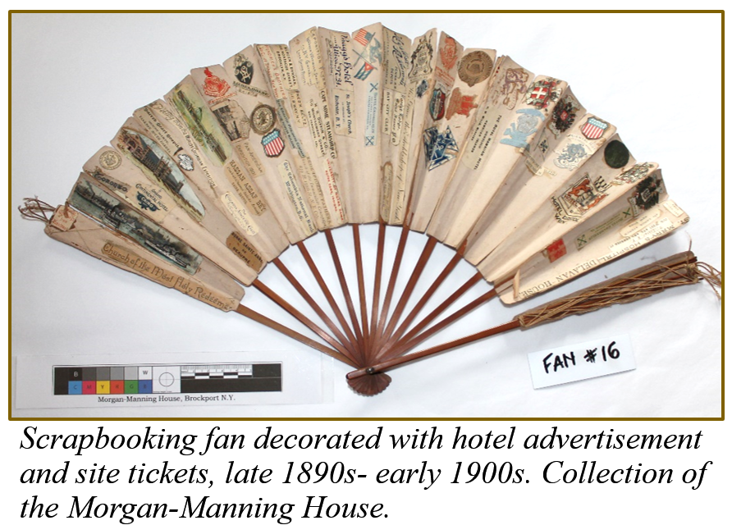
The folding fan so popular for women of the Victorian era originated in Japan in the 7th century CE. With trade flourishing between Asia and Europe from the 16th century onwards, Europeans and later Americans came to appreciate this new cooling device. Originally solely owned by the wealthy, who could afford exquisite handmade fans, the development of machine-made and mass-produced fans rendered them affordable for a wider section of society. The ladies of the Morgan family owned a small collection of fans, some made with paper and silk, while others may have had feathers dyed to match the color of a specific evening dress.
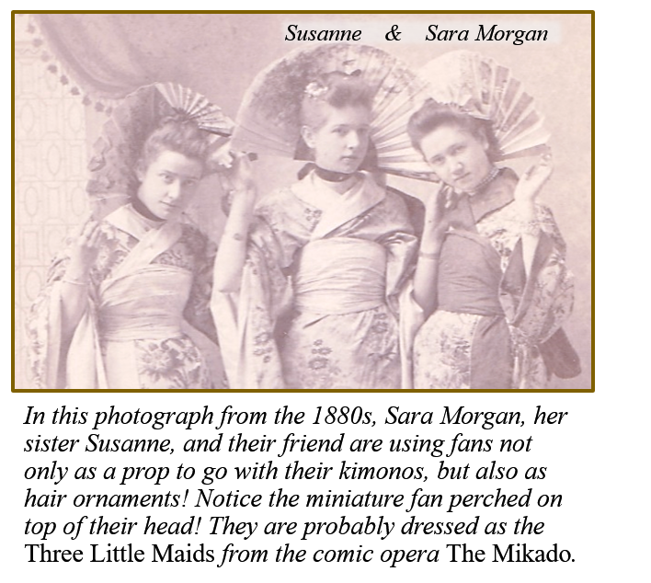
Fans lost their popularity as fashion accessories in the 1930s, but instead became a platform used by advertisers to promote companies, goods, and even politicians. While much less common today, they stilll are a welcome reprieve from the heat when all other technological options fail!
In addition to battling the heat, the summer months were also spent working with SUNY Brockport intern Kristin Strong, who returned to the MMH to complete a 2nd internship for her Museum Studies minor. I will let her describe her project and we both invite you to come and see her excellent work:
“As you may have read in the last newsletter, work has been underway in the Summer Kitchen to create a new exhibit! This is my second internship at the MMH, and I decided that my project would be to freshen up the displays of this room and create a new narrative. It was a bit daunting at first with just how much stuff was filling every available surface, and if you came through on a tour in August, you may have seen it all laid out in the parlor and dining room. Many objects were removed to storage either because they were duplicates or because they would not have been found in a 1890s summer kitchen. Once the sheer number of objects had been scaled down, I found it easier to create the story we wanted to share with guests.
The Summer Kitchen is a new exhibit on the first floor of the MMH. As you walk around the room, you will see the many tools it took to accomplish the multiple chores that Susan Morgan and her daughters, their cook and servants needed to do to keep the house running on a daily basis. The room is subtly sectioned into what the early 1900s “Science of Housewifery” referred to as “the four branches of housework”: cooking, cleaning, laundry, and the specific tasks of cleaning and airing out bedrooms known as chamber work.” Admittedly, there were only a handful of cleaning tools found in the kitchen, now gathered in the corner by the back door, so we supplemented the chamber work with a baking section, which can be found in the Hoosier cabinet. While cataloging every object in the room, Dr. Rozenn and I encountered several objects that were original to the MMH!

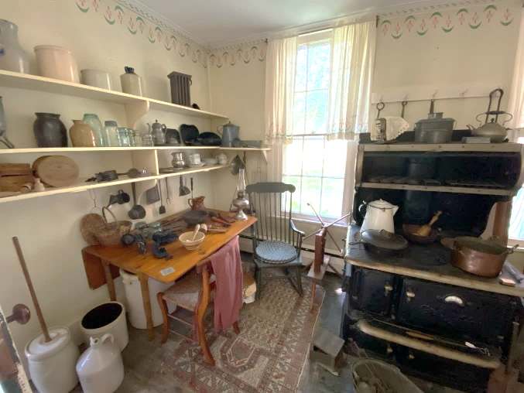
The Cooking and Canning corner in Kristin’s new exhibit.
As the end of my five weeks in the house drew near, it occasionally felt like I was trying to sprint to the finish line that I had set. On my last day as an intern, with everything in place in the room and officially cataloged, I felt like I had finally crossed that finish line and could just stand in the room and absorb what I had just accomplished during the summer term. It looks like a completely different room than the one I walked into on July 5th, but at the same time I can also hardly remember what the “old room” looked like! My time in the MMH as an intern may be over for now, but with how much the house has grown on me since the start of 2022, I will absolutely be back to visit again for the rest of my time as a student at Brockport.
Enjoy this new exhibit!”
Kristin Strong, Intern and Rozenn Bailleul-LeSuer, Curator
Thank you to:
- Eugene Korber for his donation in memory of his wife Janie.
- Jennifer & Scott Ames, Nancy Bartlett, Ann & Thomas Burger, Marilyn Cornish, Jack Donahue, Janice Dorgan, Kathleen & Brian Fox, Charlie Garlock, Ann & Robert Getz, Lynne and Allyn Hammel, Kathleen & John Kutolowski, Pat & Archie Kutz, Erica & Jeremy Linden, Donna Mancuso, Maureen McGlynn, Marilyn & William Privett, Eileen Ryerse, Barbara Sherwood, Jeannette & Delmont Smith for their donations.
September 2022 CALENDAR

September 5 – Monday– Labor Day: Office Closed

September 10 – Saturday – 9 am-2 pm – Peddlers Market, Community Household & Carriage House Sale

September 13 Tuesday – 7 pm – Board Meeting

September 29 – Thursday– 6-8 pm – “Prepare for Departure” - Book reading by Mark Chesnut

MISSION STATEMENT:

The Western Monroe Historical Society is committed to educating diverse audiences on the life and times of the Morgan-Manning house; preserving this Brockport landmark as a historical museum; providing a repository for a collection of archival materials and artifacts related to the Morgan family; and extending its legacy.

Western Monroe Historical Society - Morgan Manning House
151 Main Street, Brockport, NY 14420-1909
Office Hours Monday-Friday 9:30 am to 1:30 pm 585-637-3645
www.morganmanninghouse.org E-mail: morganmanninghouse@gmail.com
Follow us on Instagram!

Western Monroe Historical Society
NON-PROFIT ORGANIZATION
U.S. POSTAGE
P A I D
BROCKPORT, N.Y.
Permit No. 32
Morgan-Manning House
151 Main Street
Brockport, NY 14420-1909

--------

These fine businesses in the Brockport area are supporters of the Western Monroe Historical Society. We encourage you to patronize them.

Arjuna Florist and Design Shoppe
Bittersweet
Brad's Northside Service
Brockport Animal Hospital
Brockport Auxiliary
Brockport Custom Carpet
Brockport Optometry - Dr. Raff
Carriage Place & Antique Co-op
Coleen’s Kitchen
Dunn's Furnishings, Inc.
58 Main BBQ & Brew
Five Star Bank
Fowler Funeral Home, Inc.
Kirby's Farm Market
Klafehn Heise & Johnson, PLLC
Lift Bridge Book Shop
Mahan Discount Liquor & Wine, Inc.
Oakes Tree Service
QCA Corp./Lighting
Robb Farms
Sara's Garden Center
Strong West – Brockport
The Victorian Bed & Breakfast
The White Farm Bed & Breakfast
Thomas E. Burger Funeral Home
Trader Shag’s Emporium
Maxwell Thaney, DDS - Brockport Smiles
Westside News Inc.

